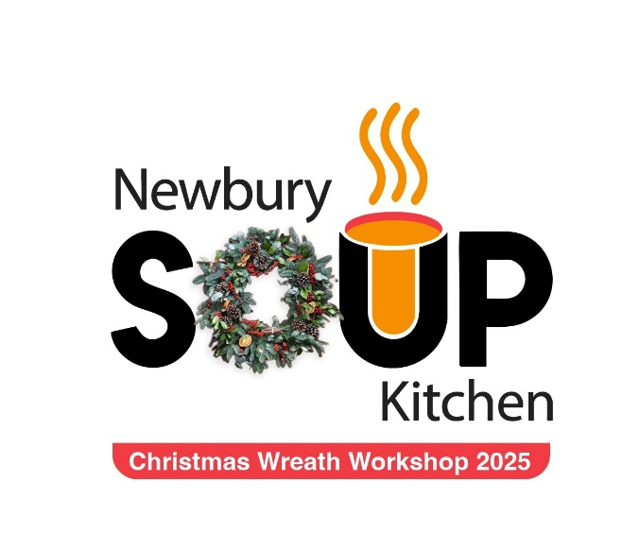

Christmas Wreath Workshop Allium Design &
Newbury Soup Kitchen
*****
with Afternoon Tea
at The Vineyard Hotel & Spa

£95 per person

Date: | 21st November 2025
Time: | 12.30pm – 5pm
Venue: | The Vineyard Hotel and Spa, Stockcross, Newbury.  Berkshire RG20 BJU

Christmas Wreath Workshop at The Vineyard
Booking Form
The Vineyard, Stockcross, Newbury, Berkshire. RG20 BJU
21st November 2025
The cost of the ticket includes
- 12.30pm Welcome, Tea and Coffee
- 1pm -4pm wreath workshop Please bring an apron and secateurs
- 4pm afternoon tea with a glass of All Angels Sparkling Rosé

Information required in this form is for allergies and dietary preferences
Otherwise please email Meryl your allergies and dietary preferences.

Main contact details
Title: | First Name: |  | Surname:
Email: |  | Mobile No:

Attendee dietary requirements and allergies
NAME | SPECIAL DIETARY REQUIREMENTS
Booking Requirements:
I require ______ticket/s for the Newbury Soup Christmas Wreath Workshop £95 per person
Please state how you would like to pay for your Tickets: Invoice ☐ Bank Transfer ☐
Please make payment to:
Newbury Soup Kitchen
Account Type: Business
Account Number: 39018055
Sort Code: 23-05-80 Tickets are confirmed on FULL payment
Please use your name as the reference

Instructions
RSVP: Please return this form to events@newburysoupkitchen.org.uk or alternatively you can post this form to Meryl Praill at Newbury Soup Kitchen, 1 Hambridge Lane, Newbury, Berkshire, RG14 5TU.
Please contact The Vineyard directly for further information regarding the hotel facilities Tel: 01635 528770
Information & Contact: For all other enquiries about Newbury Soup Kitchen or the wreath workshop please contact CEO Meryl Praill at 0758 3637588 events@newburysoupkitchen.org.uk

Thank you for supporting Newbury Soup Kitchen
We look forward to seeing you at The Vineyard on 21st November 2025
Kind Regards,


